**Some common points:**

1. In meta part entity will not change
   1. Example : <journal-title>SPE Drilling **&amp;** Completion</journal-title>”
   2. <abbrev-journal-title>
   3. <kwd>in <named-content>
2. Don’t forget to check in <issn attribute
   1. Example : <issn pub-**type="epub**">
3. If in contrib there are total 4 or more than authors but having 3 author same affiliation then id will go as “aff1” and for fourth one having second affiliation then id should be “aff2”
   1. <contrib contrib-type="author"><name><surname>Bailey</surname><given-names>W. J.</given-names></name>

<xref ref-type="aff" rid="aff1"/>

* 1. <contrib contrib-type="author"><name><surname>Peden</surname><given-names>J. M.</given-names></name>

<xref ref-type="aff" rid="aff2"/>

1. If in contrib there are asterisk footnote check the xref tag for footnote and author notes tag will code after end of affiliation
   1. <contrib contrib-type="author"><name><surname>Bailey</surname><given-names>W. J.</given-names></name>

<xref ref-type="aff" rid="aff1"/><xref ref-type="author-notes" rid="fn1"/>

* 1. <aff id="aff1">Heriot-Watt U.</aff>

<author-notes>

<fn id="fn1" fn-type="other">

<label>&#x002A;</label>

<p>Now with Schlumberger.</p>

</fn>

</author-notes>

1. In abstract having 2 section 1. Is Summary heading And second one is <abstract>, then take both the information in <abstract>
   1. <abstract>

<title>Summary</title>

<p>……</p>

<sec>

<title>Abstract>

<p>…..</p>

* 1. If the Abstract is not available in input then use the first 3 available paragraphs as “Abstract” from body part and don’t take the title.
     1. <abstract>

<p>….</p>

<p>….</p>

<p>….</p>

</abstract>

1. For More than 2 main section we can take sec-type
   1. Example: sec sec-type=”methods”>

<title>Methods</title>

1. If in pdf having “Ref 6” while giving id don’t include “Ref” word in <xref linking
   1. Example : Ref <xref ref-type="bibr" rid="R9">9</xref>
2. Figure, Table will moved as per its first call out
3. this type of equation will code as per pdf only, this will not merge and also the alignment should be match, under equal sign plus sign have to come
4. Always use “<table frame="box" rules="groups">” for below mentioned type of tables



1. Figure and table casing should be as per pdf



1. Display equation id “<disp-formula id="eq15">”
2. Inline formula id not required but code the inline equation under <inline-formula>
3. For apos entity use &#x0027; and double quote &#x22;
4. Appendix – code the appendix in <app-group>, Link the **callout to appendix** in the article
   1. Example:



<app-group>

<app id="app1">

<label>Appendix</label>

<title>Physical Properties of Acid Systems</title>

1. Always move SI metrics section after end of </glossary>, if glossary and ack not presented in pdf then it will move after end </fn-group>
2. 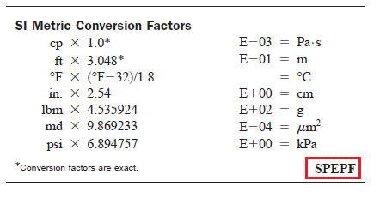 Above type of images should always have position float
   1. <table frame="hsides" rules="none">
   2. Red highlighted box data will not come
   3. Provide the table ID for SI metric section
      1. <table-wrap id="T#" position="float">
   4. For table footnote reproduced ID like this

<table-wrap-foot>

<fn fn-type="**other" id="TFN1"><**label>&#x002A;</label><p>Conversion factors are exact.</p></fn>

</table-wrap-foot>

1. If table foot doesn’t have call out then don’t reproduce the ID
   1. <table-wrap-foot>

<fn fn-type="other"><label>&#x002A;</label><p>The Sherwood number was calculated using <xref ref-type="disp-formula" rid="eq4">Eq. 4</xref>.</p>

1. In Glossary having more title for each and every title should have term head and def head
   1. <def-list>

<title>Subscripts</title>

<term-head>Abbreviation</term-head>

<def-head>Expansion</def-head>

1. In Appendix all the figure and table position should be anchor
2. In Contrib author footnote
   1. <xref ref-type="author-notes" rid="FN1"/>
   2. In para <xref ref-type=”fn" rid="FN1">&#x002A;</xref>
   3. In table wrap foot <xref ref-type="tfn" rid="TFN1"><sup>1</sup></xref> continue the ID
3. In footnote for asterisk (&#x002A;) superscript tag will not come, other entity footnote will come in footnote (&#x2020;)
4. Ref 1 link should be “Ref <xref ref-type="bibr" rid="R1">1</xref>
5. If range appeared in references <sup><xref ref-type="bibr" rid="R1">1</xref>&#x2013; <xref ref-type="bibr" rid="R1">1</xref></sup>
6. In meta history info provided then also take it from pdf

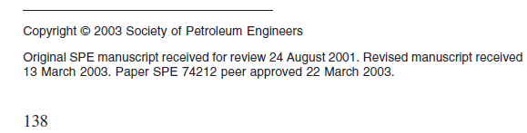

<history>

<date date-type="received"><day>24</day><month>8</month><year>2001</year></date>

<date date-type="rev-recd"><day>13</day><month>3</month><year>2003</year></date>

<date date-type="accepted"><day>22</day><month>3</month><year>2003</year></date>

</history>

For Main section sec type will come below are the list

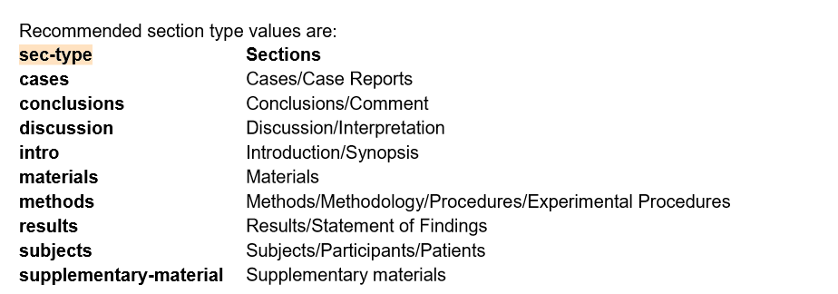

* 1. Article Title

Ensure the casing of article title is in title case

<title-group>

<article-title>Global Management with Local Intentions</article-title>

</title-group>

If the colon appears in the title, wrap up in the title. Do not code the <sub-title>

* 1. Author Group

1. Code the author name using <name>
2. DO NOT CODE DUMMY AFFILIATION LINK AND LABELS

<contrib-group>

<contrib contrib-type="author"><name><surname>Jablonowski</surname><given- names>Christopher J</given-names></name></contrib></contrib-group>

1. Initials coding in author name (6th April 2015)

Space should be added if an author has two initials in their name

For example, J.S. Smith, XYZ Company should become J. S. Smith, XYZ Company.

<contrib contrib-type="author"><name><surname>Smith</surname><given-names>J. S.</given- names></name>

* 1. Author Affiliation –

The author affiliations citation labels are standardized to „numerical‟. They appear, when there is more than one affiliation.

If the affiliation text is “**SPE**” do not code the data in XML

Eg:

## Input: Laurent Jammes, SPE, Actys-BEE

Xml coding: <aff>Actys-BEE</aff>

#### Input:

**Global Management with Local Intentions**

Allan Campbell, Maersk Oil, Karen Grønfeldt Henriksen, Maersk Oil, Aude Savariau, Maersk Oil, Martin Torp Jensen, Maersk Oil, Daniel Stephansen, Maersk Oil

#### XML coding:

<title-group>

<article-title>Global Management with Local Intentions</article-title>

</title-group>

<contrib-group>

<contrib contrib-type="author"><name><surname>Campbell</surname><given- names>Allan</given-names></name>

</contrib>

<contrib contrib-type="author"><name><surname>Henriksen</surname><given-names>Karen Gr&#x00F8;nfeldt</given-names></name>

</contrib>

<contrib contrib-type="author"><name><surname>Savariau</surname><given-names>Aude</given- names></name>

</contrib>

<contrib contrib-type="author"><name><surname>Jensen</surname><given-names>Martin Torp</given-names></name>

</contrib>

<contrib contrib-type="author"><name><surname>Stephansen</surname><given- names>Daniel</given-names></name>

</contrib>

<aff>Maersk Oil</aff>

</contrib-group>

* + IF only “SPE” is present as affiliation in input then do not code the same in xml as

<aff>.

As client has instructed that **“please note SPE should not be anywhere in the**

# author lines.”

## In below example, “SPE” is not coded as <aff> for John Tulett but all authors are coded in single <contrib-group>.

#### Input:



**XML coding for multiple affiliations:**

<contrib-group>

<contrib contrib-type="author"><name><surname>Tulett</surname><given-names>John</given- names></name>

</contrib>

<contrib contrib-type="author"><name><surname>Dean</surname><given-names>Timothy</given- names></name>

</contrib>

<contrib contrib-type="author"><name><surname>Lane</surname><given-names>Darvin</given- names></name>

</contrib>

<aff>Schlumberger</aff>

</contrib-group>

* + Client has instructed that **“There should not be any addresses**

**in the author lines.”** i.e. do not code City, State or Country names in affiliation even if they are present in Input/source file

# e.g.

## In below example, data in red square should not be coded in <aff> in xml



<contrib-group>

<contrib contrib-type="author">

<name><surname>Mongy</surname><given-names>Mohamed A.</given-names></name></contrib>

<aff>Universiti Teknologi PETRONAS (UTP)</aff>

</contrib-group>

<contrib-group>

<contrib contrib-type="author">

<name><surname>Shedid</surname><given-names>Shedid A.</given-names></name></contrib>

<aff>American University in Cairo (AUC) &#x0026; Schlumberger-NExT</aff>

</contrib-group>

**Author name sequence (22-Apr-14)**

### Author names in author-group should appear in sequence. e.g.

Fangfu Zhang (**Rice University**), Chao Yan (Brine Chemistry Solutions), Narayan Bhandari (**Rice University**), Amy T. Kan (**Rice University**), and Mason B. Tomson (**Rice University**)

Author group should appear as

Fangfu Zhang, Rice University;

Chao Yan, Brine Chemistry Solutions;

Narayan Bhandari, Amy T. Kan, and Mason B. Tomson, Rice University

* 1. Publication Date – The pub date information is to be extracted from the conference information date

This paper was prepared for presentation at the SPE International Conference on Health, Safety, and Environment held in Long Beach, California, USA, 17–19 March 2014.

## <pub-date pub-type="epub">

<day>17</day>

<month>3</month>

<year>2014</year>

</pub-date>

<pub-date pub-type="ppub">

<year>2014</year>

</pub-date>

### Add <volume>, <issue>, <fpage> and <lpage>

</pub-date>

<volume>[Year]</volume> ---- Code year in <volume> element.

<issue>[Month]</issue> ---- Code month from <pub-date> as <issue> element.

### <isbn>…</isbn> ---- Code from metadata doc provided.

<fpage></fpage> ---- Keep fpage and lpage element empty until further information.

<lpage></lpage>

Eg:

</pub-date>

<volume>2014</volume>

<issue>3</issue>

<isbn>978-1-61399-305-7</isbn>

<fpage></fpage>

<lpage></lpage>

* 1. Copyright Statement, License – code the copyright info and license as stated below:

#### SPE

<permissions>

<copyright-statement>Copyright 2014, Society of Petroleum Engineers</copyright-statement>

<copyright-year>2014</copyright-year>

<copyright-holder>SPE</copyright-holder>

<license license-type="ccc">

<license-p>PROC</license-p>

</license>

<license license-type="pricing">

<license-p>

<price content-type="price-code">SPEMTG</price>

</license-p>

</license>

</permissions>

#### OTC

<permissions>

<copyright-statement>Copyright 2014, Offshore Technology Conference</copyright-statement>

<copyright-year>2014</copyright-year>

<copyright-holder>OTC</copyright-holder>

<license license-type="ccc">

<license-p>PROC</license-p>

</license>

<license license-type="pricing">

<license-p>

<price content-type="price-code">OTCMTG</price>

</license-p>

</license>

</permissions>

1. PDF link in XML –

<self-uri xlink:href="journalcode-paper number.pdf" content-type="pdf"></self-uri>

<self-uri xlink:href="SPE-168315-MS.pdf" content-type="pdf"></self-uri>

1. Abstract –
   1. Code the title <title>Abstract</title> regardless of its appearance in inputs
   2. Ensure to emphasize the text appearing in between the <p>
   3. If the Abstract is not available in input then use the first 3 available paragraphs as “Abstract”
2. Key Words – code the keywords title if it appears in the inputs:

<kwd-group>

<title>Key Words:</title>

<kwd>Elderly Patients</kwd>

….

</kwd-group>

1. Conference Information – Derive the conference information from the footnote mentioned below

XML coding:

<conference>

<conf-date iso-8601-date="2014-04-19">19 April-25 April</conf-date>

<conf-name>SPE Western Regional &#x0026; AAPG Pacific Section Meeting, 2013 Joint Technical Conference</conf-name>

<conf-acronym>JTC</conf-acronym> [will be provided by Customer]

<conf-loc>Monterey, California, USA</conf-loc>

</conference>

Note: "0" paddind not required for single digit number

e.g.: <conf-date iso-8601-date="2015-03-01">1-5 March</conf-date>

1. Page count

Coded the page count of the paper instead of codes <fpage> and <lpage>

<counts>

<page-count count="13"/>

</counts>

1. Custom-meta

### </counts>

<custom-meta-group>

<custom-meta>

<meta-name>Peer Reviewed</meta-name>

<meta-value>false</meta-value>

</custom-meta>

</custom-meta-group>

1. Body Section

#### Section

Identify the section level and code accordingly. Make sure to nest the sections.

Do not code sec ids unless there is a requirement to link the section. Use sec-type for all the section wherever it is applicable as per the DTD.

|  |  |
| --- | --- |
| Recommended section type values are: | |
| **sec-type** | **Sections** |
| **cases** | Cases/Case Reports |
| **conclusions** | Conclusions/Comment |
| **discussion** | Discussion/Interpretation |
| **intro** | Introduction/Synopsis |
| **materials** | Materials |
| **methods** | Methods/Methodology/Procedures/Experimental Procedures |
| **results** | Results/Statement of Findings |
| **subjects** | Subjects/Participants/Patients |
| **supplementary-material** | Supplementary materials |

#### Display Quote

Code the indented text in <disp-quote>.

PDF:

The well published author on altitude related health issues, J.B.West, reference 24,25,86 notes in the ILO altitude document (2008) that:

*"…this increase in ventilation is one of the most important features of the acclimatization process, and therefore it is reasonable to recommend that the working period at high altitude be at least ten days.*

XML:

<disp-quote>

<p><italic>&#x201C;&#x2026;this increase in ventilation is one of the most important features of the acclimatization process, and therefore it is reasonable to recommend that the working period at high altitude be at least ten days</italic>.</p>

#### List

Code list-type as order, bullet, alpha-lower, alpha-upper, roman-lower, roman-upper,

**unordered** and simple as per the DTD.

- Paragraph shoulc be closed (</p>) before list element i.e. list should be coded outside paragraph

e.g.

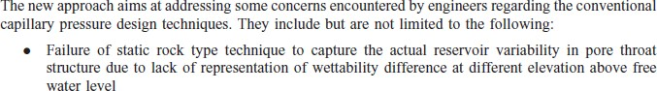

<p>The new approach aims at addressing some concerns encountered by engineers regarding the conventional capillary pressure design techniques. They include but are not limited to the following:**</p>**

<list list-type=”bullet”>

<list-item><p>Failure of static ro….

.

.

.

</list>

<p>……

- list-item paragraphs are to be closed before starting sub list item e.g.

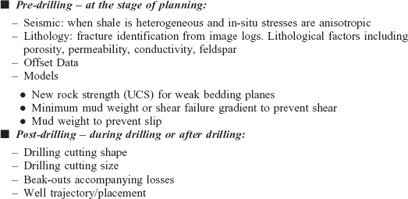

<list list-type="unordered">

<list-item><label>&#x25A0;</label> <p><bold><italic>Post-drilling &#x2013; during drilling or after drilling:</italic></bold>**</p>**

**<p>**<list list-type="simple">

<list-item><label>&#x2013;</label> <p>Drilling cutting shape</p></list-

item> item>

<list-item><label>&#x2013;</label> <p>Drilling cutting size</p></list-

<list-item><label>&#x2013;</label> <p>Beak-outs accompanying

losses</p></list-item>

<list-item><label>&#x2013;</label> <p>Well trajectory/placement</p></list-item>

</list>

**</p>**

</list-item>

</list>

.

-List-type should be “simple” for hyphenated list. Use “&#x2013;” in label instead of “-“.

-If list is other than “order, bullet, alpha-lower, alpha-upper, roman-lower, roman-upper, simple” then should be coded as “**unordered**”.

If the list is in square filled or any other style must be coded as below. Example if you come across square list type.

1)

XML Coding:

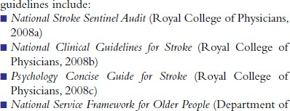

<list list-type="unordered">

<list-item><label>&#x25AA; </label><p><italic>National Stroke Sentinel Audit</italic> (<xref ref-type="bibr" rid="B28">Royal College of Physicians, 2008a</xref>)</p></list-item>

#### Tables

* + 1. Code the Table using CALS (HTML) model.
    2. Code the reference callouts appearing in tables
    3. Place Tables/Figures after the para in which the first callout appears. Also the placement should be in sequential order.
    4. Casing of rid and id of figures, tables and equations should be same.
    5. Do not use “fu#” or “tu#” as id for unnumbered figures and table instead use ids after normal figures and tables i.e. if article is having 5 figures then use ids from “fig6” for unnumbered figures. (use same naming convention for tables)
    6. Do not expand the callouts of tables appearing in range. e.g.: tables 1 to 4

XML Coding**:**

<xref ref-type="table" rid="T1">tables 1</xref> to <xref ref- type="table" rid="T4">4</xref>

* + 1. Use <break/> tag if the heading or text is too long.
    2. Use <hr/> if applicable
    3. For one indent use 4 times &#x2003;
    4. Code the URL links in tables
    5. Label should be coded in title case and should be contain complete “Table” word

i.e. it should be <label>Table #</label> irrespective of input. (where # is table no.).

* + 1. Use position attribute "float".
    2. <p> should be used within <caption>. Do not use <title>
    3. Use @frame & @rules attribute in <table> to match the Border as per input. Use Table_Borders.xls (provided separately) for the values of both the attributes.
    4. Use of @width in <table>
       1. If table covers entire width of the input page then it is considered as “100%” and hence in this case @width is not required.
       2. But if table do not covers entire width of the input page then @width should be used in <table> and the value should be in percentage (%). The percentage should be decided depending upon the width area covered by the table considering the entire width of input page as 100%.

i.e. if table covers half width of the table then value of @width should be “50%”.

e.g.

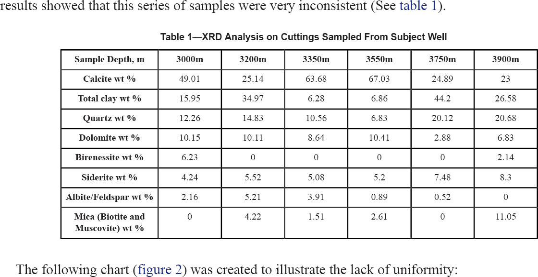

XML Coding**:**

<table-wrap id="T1" position="float">

<label>Table 1</label>

<caption><p>XRD Analysis on Cuttings Sampled From Subject Well</p></caption>

<table frame="box" rules="all" width="**90%**">

1. Use of @width in <col>
   1. If all the columns of a table are of same width then @width is not required in

<col>.

* 1. If column widths are different then @width should be used. The entire table should be considered as 100% and then percentage of the widest column should be decided. For remaining columns percentage is calculated as;

Percentage of the remaining columns=100%-percentage of the widest column

No. of remaining columns

e.g.



XML Coding**:**

<colgroup>

<col width="20%"/>

<col width="13%"/>

<col width="13%"/>

<col width="13%"/>

<col width="13%"/>

<col width="13%"/>

<col width="13%"/>

</colgroup>

In above example, widths of all columns are not equal and first column is the widest column. Hence, it‟s width is decided as “20%” of the entire table. Percentage of remaining columns is calculated as

Percentage of the remaining columns=100%- percentage of the widest column

No. of remaining columns

Here, 100-20 = 13.33.

6

Hence, percentage of remaining columns are coded as “13%”

1. Use of @align
   1. @align is compulsory in all the <th> and <td> including their dummy tags (<th/> and <td/>). Proper alignment should be used according to the input. ”.
   2. Do not use @align in <col>.
2. While setting alignment use only non-character alignments i.e. “center”, “left”, “right.
3. Coding of @valign (vertical alignment) is required in each and every cell i.e. in all

<td> and <th>.

Hence, now @valign is not required for <thead> and <tbody>.

e.g.



XML Coding**:**

<thead>

<tr align="center">

<th align="center" valign="**middle**">Sample Depth, m</th>

<th align="center" valign="**middle**">3000m</th>

<th align="center" valign="**middle**">3200m</th>

<th align="center" valign="**middle**">3350m</th>

<th align="center" valign="**middle**">3550m</th>

<th align="center" valign="**middle**">3750m</th>

<th align="center" valign="**middle**">3900m</th></tr>

</thead>

1. Do not code the source info in <attrib>.

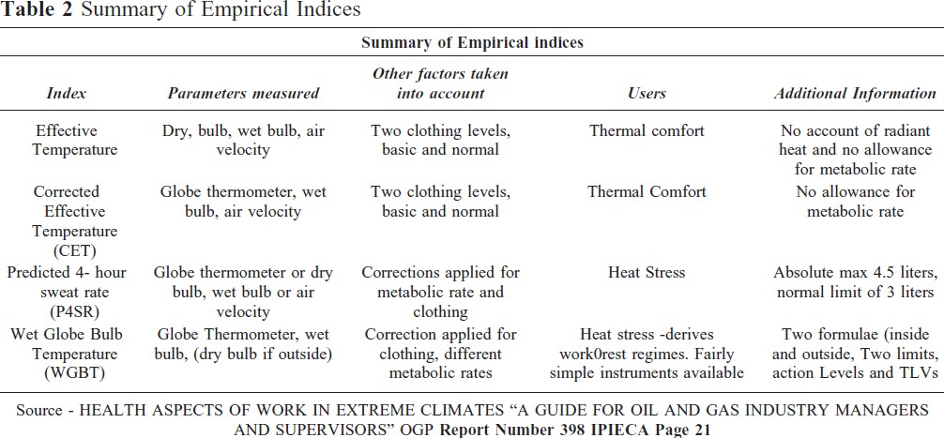

XML coding:

</table>

<table-wrap-foot>

<fn fn-type=”other”>Source - HEALTH ASPECTS OF WORK IN EXTREME CLIMATES &#x201C;A GUIDE FOR OIL AND GAS INDUSTRY MANAGERS AND SUPERVISORS&#x201D; OGP

<bold>Report Number 398 IPIECA Page 21</bold></fn>

</table-wrap-foot>

</table-wrap>

1. @fn-type is required in all table footnotes

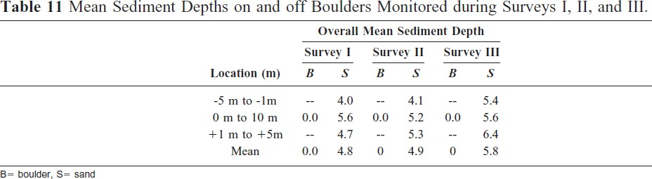

XML coding:

</table>

<table-wrap-foot>

<fn fn-type="abbr"><p>B= boulder, S= sand</p></fn>

</table-wrap-foot>

</table-wrap>

1. 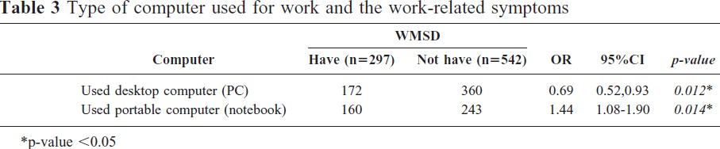Links should be coded for table footnote callouts and attribute values should be “TFN#” (where # is footnote no. in increasing order)

XML coding:

<table-wrap id="T3" position="float">

<label>Table 3</label>

<caption><p>Type of computer used for work and the work-related symptoms</p></caption>

<table frame="hsides" rules=”groups”>

.

.

.

<tbody>

<tr>

<td>Used desktop computer (PC)</td>

<td>172</td>

<td>360</td>

<td>0.69</td>

<td>0.52,0.93</td>

<td><italic>0.012</italic><xref ref-type="table-fn" rid**="TFN1"**>&#x002A;</xref></td>

</tr>

<tr>

<td>Used portable computer (notebook)</td>

<td>160</td>

<td>243</td>

<td>1.44</td>

<td>1.08-1.90</td>

<td><italic>0.014</italic><xref ref-type="table-fn" rid=**"TFN1"**>&#x002A;</xref></td>

</tr>

</tbody>

</table>

<table-wrap-foot>

<fn fn-type="other" id="**TFN1**"><label>&#x002A;</label><p>p-value &#x003C;0.05</p></fn>

</table-wrap-foot>

</table-wrap>

1. Coding of Unnumbered Tables
   1. If the table is unnumbered/uncalled, the placement must be as per the input
   2. Dummy callout must be given before the placement

XML coding:

<p>The……...<xref ref-type="table" rid="T#"/></p>

<table-wrap id="T#" position="float">

<table frame="hsides">

<colgroup>

<col align="left"/>

<col align="left"/>

</colgroup>

<thead valign="bottom">……

1. Coding of Graphic Tables Code table graphic for:
2. coloured tables
3. shaded tables and/or tables which have a coloured background
4. tables having large no. of inline-equations in it

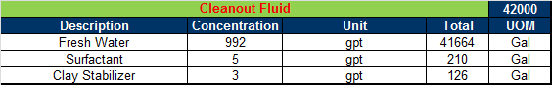

XML coding:

<table-wrap id="T1" position="float">

<label>Table 1</label>

<caption><p>Basic parameters and min/max possible values at depth 335mbsf.</p></caption>

<table frame="hsides">

<colgroup>

<col align="center"/>

</colgroup>

<tbody valign="top">

<tr>

<td><graphic [xmlns:xlink="http://www.w3.org/1999/xlink"](http://www.w3.org/1999/xlink) xlink:href="OTC-25326- MS_t_01.tif"/></td>

</tr>

</tbody>

</table>

</table-wrap>

#### Figures/Photo:

1. Label should be coded in title case i.e. lit should be <label>Figure 1</label> regardless of the callouts in pdf (avoid usage of Fig.)
2. Do not expand the callouts of figures in range

Eg: figs. 1 to 4 XML Coding:

<xref ref-type="fig" rid="F1">figs. 1</xref> to <xref ref-type="fig" rid="F4">4</xref>

1. Do not code <attrib> element in Figure coding. It should be coded in caption. As shown below;

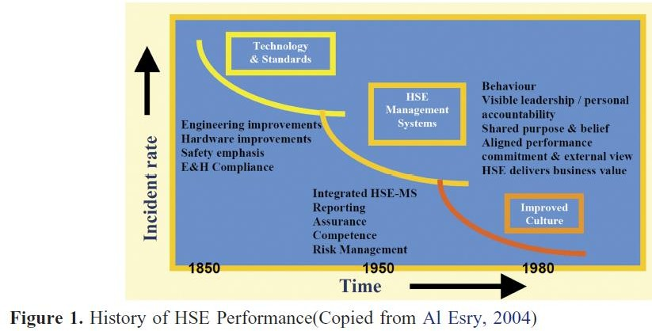

XML coding:

<fig id="F1" position="float">

<label>Figure 1</label> [do not retain punctuation in figure and table “label”]

<caption><p>History of HSE Performance (Copied from <xref ref-type="bibr" rid="R1">Al Esry, 2004</xref>)</p></caption>

<graphic [xmlns:xlink="http://www.w3.org/1999/xlink"](http://www.w3.org/1999/xlink) xlink:href="SPE-168332- MS_fig_01.tif"/>

</fig>

1. Coding of unnumbered figures:
   1. If the figure is unnumbered the placement must be as per the input
   2. Dummy callout must be given before the placement

XML coding:

<p>the …………. <xref ref-type="fig" rid="Fig1"/></p>

<fig id="Fig1" position="float">

<graphic [xmlns:xlink="http://www.w3.org/1](http://www.w3.org/1999/xlink)999/xlink" xlink:href="SPE-168332- MS_fig_01.tif"/>

</fig>

1. Casing of rid and id of figures, tables and equations should be same.
2. Do not use “fu#” or “tu#” as id for unnumbered figures and table instead use ids after normal figures and tables i.e. if article is having 5 figures then use ids from “fig6” for unnumbered figures. (use same naming convention for tables)

#### File naming convention:

Figure, equation, table name can be formatted as

### SPE-25397-MS_eq_01.tif SPE-25397-MS_ineq_01.tif SPE-25397-MS_fig_01.tif SPE-25397-MS_t_01.tif

Graphic type should be lower case.

#### URL links - Code the web links using <ext-link>:

<p><ext-link ext-link-type="uri" [xmlns:xlink="http://www.w3.org/1999/xlink"](http://www.w3.org/1999/xlink) [xlink:href="http://www.hse.gov.uk/temperature/heatstress/riskassessment.pdf">ht](http://www.hse.gov.uk/temperature/heatstress/riskassessment.pdf) [tp://www.hse.gov.uk/temperature/heatstress/riskassessment.pdf</ext](http://www.hse.gov.uk/temperature/heatstress/riskassessment.pdf)-link>

#### URL links for doi no.:

**e.g. “**10.1029/2011JB008218” will be coded as

<ext-link ext-link-type="doi" [xmlns:xlink="http://www.w3.org/1999/xlink"](http://www.w3.org/1999/xlink) xlink:href="[**http://dx.doi.org/**10.1029/2011JB008218">10.1029/2011JB00](http://dx.doi.org/10.1029/2011JB008218) 8218</ext-link>

#### Coding of Equation:

* 1. The coding of the display equations are should be placed as per input and not as per their callouts.
  2. Do not expand the callouts of equations in range

<xref ref-type="disp-formula" rid="eq7 eq8 eq9">Eqs. (7)</xref> - <xref ref- type="disp-formula" rid="eq10">(10)</xref>

Should be

<xref ref-type="disp-formula" rid="**eq7**">Eqs. (7)</xref> - <xref ref-type="disp- formula" rid="**eq10**">(10)</xref>

* 1. “id” should be coded for unlabelled display formulas.

#### Input:

|  |  |
| --- | --- |
|  | (1) |

XML coding:

<disp-formula id="eq1">

<label>(1)</label>

<graphic [xmlns:xlink="http://www.w3.org/1999/xlink"](http://www.w3.org/1999/xlink) xlink:href="SPE-168308- MS_eq_01.tif"/>

</disp-formula>

3) Code the description of the equations that appear below the equation in <def-list> e.g.



<p>with</p>

<def-list>

<def-item><term>&#x0394;T</term>

<def><p>- temperature change</p></def>

</def-item>

<def-item><term>t</term>

<def><p>- time</p></def>

</def-item></def-list>

#### j. Coding of inline-equation:

1. If inline equations are codable then do not use <inline-graphic> for the same instead key/code the data.

Example 1:

In above example, <inline-graphic> is not required for the data in square as we can key it. Example 2:

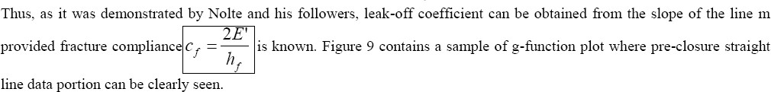In above example, <inline-graphic> coding is required for the data in square.

1. Do not code inline-equations in <graphic> element instead use <inline-graphic>.

<**graphic** [xmlns:xlink="http://www.w3.org/1999/xlink"](http://www.w3.org/1999/xlink) xlink:href="SPE- 172384-MS_**ineq**_01.tif"/>

Should be

<**inline-graphic** [xmlns:xlink="http://www.w3.org/1999/xlink"](http://www.w3.org/1999/xlink) xlink:href="SPE-172384-MS_**ineq**_01.tif"/>

1. While coding disp-formula, the preceding para should not be ended if it ends with a : (colon)

<p>Sequestered volume by solubility storage:</p>

<disp-formula id="eq6">

<label>(6)</label>

<graphic [xmlns:xlink="http://www.w3.org/1999/xlink"](http://www.w3.org/1999/xlink) xlink:href="SPE-172354- MS_Eq_06.tif"/>

</disp-formula>

Should be

<p>Sequestered volume by solubility storage:

<disp-formula id="eq6">

<label>(6)</label>

<graphic [xmlns:xlink="http://www.w3.org/1999/xlink"](http://www.w3.org/1999/xlink) xlink:href="SPE-172354- MS_Eq_06.tif"/>

</disp-formula></p>

#### Back Matter:

The Order of back matter components such as footnotes, glossary, acknowledgements, references, appendix should be as per the input file

* 1. **Acknowledgment –** code in <ack>

<back>

<ack>

<title>Acknowledgments</title>

<p>We thank Michael Boisvert and Sarah Jacob from Chevron&#x0027;s Australian Business Unit for their preliminary development of the Snap Sampler&#x00AE; groundwater monitoring program. Thanks also to Sandy Britt of Prohydro Inc. for technical support and training provided as part of this program execution.</p>

</ack>

* 1. **Footnotes:**
* Footnote type is required for all the footnotes including the table/figure footnotes.
* Place the author related footnote in <author-notes>.
* Article related footnote in back matter before the <ref-list>.

|  |  |
| --- | --- |
|  | Attribute: type of Footnote |
| **Value** | **Meaning** |
| **abbr** | Abbreviations |
| **com** | Communicated-by information |
| **con** | Contributed-by information |
| **conflict** | Conflict of interest statements |
| **corresp** | Corresponding author information not identified separately, but merely footnoted |
| **current-aff** | Contributor‟s current affiliation |
| **deceased** | Person has died since article was written. |

|  |  |
| --- | --- |
|  | **Example of author-notes** |
| **1** | **<corresp id="cor1"><sup>2</sup>To whom correspondence should be addressed. E-mail: <email>yoshi@sc** |
| **2** | **<fn fn-type="edited-by">** |
|  | <p>Edited by Douglas C. Rees, California Institute of Technology, Pasadena, CA, and approved December 19, 2008 |
| **3** | **<fn fn-type="con">** |
|  | <p>Author contributions: T.T. and S.Y. designed research; H.A., K.M., K.S.-I., K.H., E.Y., T.T., and S.Y. performed re |
| **4** | **<fn id="FN1" fn-type="equal">** |
|  | <p><sup>1</sup>H.A., K.M., and K.S.-I. contributed equally to this work.</p></fn> |
| **5** | **<fn fn-type="com">** |
|  | <p>Communicated by Bruce D. Smith, National Museum of Natural History, Smithsonian Institution, Washington, DC |
| **6** | **<fn id="FN1" fn-type="present-address">** |
|  | <p><sup>1</sup>Present address: Lymphocyte Biology Section, Laboratory of Immunology, National Institute of Alle |
|  | **Example of footnotes** |
|  | Back matter **<fn-group>** |
| **1** | **<fn fn-type="conflict">** |
|  | <p>The authors declare no conflict of interest.</p></fn> |
| **2** | **<fn fn-type="other">** |

|  |  |
| --- | --- |
| **edited-by** | Contributor has the role of an editor. |
| **equal** | Contributed equally to the creation of the document |
| **financial- disclosure** | Statement of funding or denial of funds received in support of the research on which an article is based |
| **On-leave** | Contributor is on sabbatical or other leave of absence. |
| **other** | Some footnote type, other than those enumerated. |
| **participating- researchers** | Contributor was a researcher for an article. |
| **present-address** | Contributor‟s current address |
| **presented-at** | Conference, colloquium, or other occasion at which this paper was presented |
| **presented-by** | Contributor who presented the material |
| **previously-at** | Contributor‟s previous location or affiliation |
| **study-group-**  **members** | Contributor was a member of the study group for the research |
| **Supplementary- material** | Points to or describes supplementary material for the article |
| **supported-by** | Research upon which an article is based was supported by some entity |
| **reprint** | Method or place to obtain reprints, typically the name and address of a person from whom reprints can be requested |

|  |
| --- |
| <p>This article is a PNAS Direct Submission.</p></fn> |
| <fn fn- type="Declaration"  >  <p>Declaration of Interests Nil</p>  </fn> |

<fn fn-type="presented-at">

<p>This paper was prepared for presentation at the SPE International Conference on Health, Safety, and Environment held in Long Beach, California, USA, 17&#x2013;19 March 2014.</p>

<p>This paper was selected for presentation by an SPE program committee following review of information contained in an abstract submitted by the author(s). Contents of the paper have not been reviewed by the Society of Petroleum Engineers and are subject to correction by the author(s). The material does not necessarily reflect any position of the Society of Petroleum Engineers, its officers, or members. Electronic reproduction, distribution, or storage of any part of this paper without the written consent of the Society of Petroleum Engineers is prohibited.

Permission to reproduce in print is restricted to an abstract of not more than 300 words; illustrations may not be copied. The abstract must contain conspicuous acknowledgment of SPE copyright.</p>

</fn>

</fn-group>

1. Abbreviations / Glossary / Acronyms: Tag as suggested below:

**Acronyms**

AMS – acute mountain sickness

COPD – chronic obstructive pulmonary disease HACE – high altitude cerebral edema

HAH – High Altitude Headache

HAPE – high altitude pulmonary edema HSE – health safety and environment HVR – hyperventilatory response

ILO – international labour organization MASL – meters above sea level

SG – specific gravity

TLV – threshold limit value

**Glossary**

16 SPE-168372-MS

Hypoxia – low oxygen state

<back>

<fn-group>

….

</fn-group>

<glossary>

<def-list>

<title>Acronyms</title>

<term-head>Abbreviation</term-head>

<def-head>Expansion</def-head>

<def-item><term id="G1">AMS</term>

<def><p>&#x2013; acute mountain sickness</p></def>

</def-item>

<def-item><term id="G2">COPD</term>

<def><p>&#x2013; chronic obstructive pulmonary disease</p></def>

</def-item>

<def-item><term id="G3">HACE</term>

<def><p>&#x2013; high altitude cerebral edema</p></def>

</def-item>

<def-item><term id="G4">HAH</term>

<def><p>&#x2013; High Altitude Headache</p></def>

</def-item>

<def-item><term id="G5">HAPE</term>

<def><p>&#x2013; high altitude pulmonary edema</p></def>

</def-item>

<def-item><term id="G6">HSE</term>

<def><p>&#x2013; health safety and environment</p></def>

</def-item>

<def-item><term id="G7">HVR</term>

<def><p>&#x2013; hyperventilatory response</p></def>

</def-item>

<def-item><term id="G8">ILO</term>

<def><p>&#x2013; international labour organization</p></def>

</def-item>

<def-item><term id="G9">MASL</term>

<def><p>&#x2013; meters above sea level</p></def>

</def-item>

<def-item><term id="G10">SG</term>

<def><p>&#x2013; specific gravity</p></def>

</def-item>

<def-item><term id="G11">TLV</term>

<def><p>&#x2013; threshold limit value</p></def>

</def-item>

</def-list>

</glossary>

<glossary>

<def-list>

<title>Glossary</title>

<term-head>Abbreviation</term-head>

<def-head>Expansion</def-head>

<def-item><term id="G12">Hypoxia</term>

<def><p>&#x2013; low oxygen state</p></def>

</def-item>

</def-list>

</glossary>

1. Appendix – code the appendix in <app-group Ensure to tag unique id for individual appendix Link the callout to appendix in the article

<app-group>

<app id="app1">

<label>Appendix 1:</label>

#### References section –

* 1. Code the references using the <mixed-citation><person-group><string- name>
  2. The citations may also appear without heading
  3. For et al appearing in references please code self ending tag.
  4. For numbered references, captured period in the label irrespective of input file.
  5. If numbered references are appearing in Reference section and callouts in body are appearing as author names then do not capture <label> in the reference coding.
  6. Do not expand the callouts of references in range; Eg: Fig. 2 to 14

**<sup>**<xref ref-type="bibr" rid="R2">2</xref>&#x2013;<xref ref- type="bibr" rid="R14">14</xref>**</sup>**

* 1. Space should not be present between <label> and <mixed-citation> tags

e.g

<ref id="R1"><label>1.</label> <mixed-citation publication-type="journal"> Should be

<ref id="R1"><label>1.</label><mixed-citation publication-type="journal">

g. In publication-type="conference", the identification of data of conference and location should be as per the interpretation of the data and not as per punctuation

e.g.



### <conf-name>Paper SPE 15765 presented at the Fifth SPE Middle East Oil Show held in Manama</conf-name>. <conf-loc>Bahrain</conf-loc>. <conf-date>March 7-10</conf- date>.</mixed-citation></ref>

Corrected: <conf-name>Paper SPE 15765 presented at the Fifth SPE Middle East Oil Show</conf-name> held in **<conf-loc>Manama. Bahrain</conf-loc>.** <conf-date>March 7- 10</conf-date>.</mixed-citation></ref>

Examples:

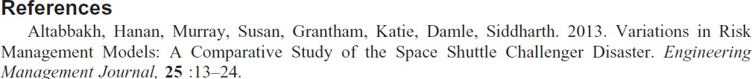

<ref id="R1"><mixed-citation publication-type="journal"><person-group person-group- type="author"><string-name><surname>Altabbakh</surname>, <given-names>Hanan</given-

names></string-name>, <string-name><surname>Murray</surname>, <given- names>Susan</given-names></string-name>, <string-name><surname>Grantham</surname>,

<given-names>Katie</given-names></string-name>, <string- name><surname>Damle</surname>, <given-names>Siddharth</given-names></string- name></person-group>. <year>2013</year>. <article-title>Variations in Risk Management Models: A Comparative Study of the Space Shuttle Challenger Disaster</article-title>.

<source>Engineering Management Journal</source>,

<volume>25</volume>:<fpage>13</fpage>&#x2013;<lpage>24</lpage>.</mixed-citation></ref>



<ref id="R2"><mixed-citation publication-type="journal"><article-title>Are We Losing Ground in Rig Safety? Some Operators Say &#x2018;Yes.&#x2019;</article-title> <year>1998</year>.

<source>Drilling Contractor</source>, <month>May/June</month>: <fpage>18</fpage>.</mixed- citation></ref>



<ref id="R3"><mixed-citation publication-type="conference"><person-group person-group- type="author"><string-name><surname>Azarkhil</surname>, <given-names>Mandana</given- names></string-name>, <string-name><surname>Mosleh</surname>, <given-names>Ali</given- names></string-name></person-group>. <year>2012</year>. <article-title>Modeling and Simulation of the Impact of Team Characteristics on Crew Performance</article-title>. <conf- name>Probabilistic Safety Assessment and Management Conference</conf-name>, <conf- loc>Helsinki, Finland</conf-loc>, <conf-date>25-29 June</conf-date>

<year>2012</year>.</mixed-citation></ref>



<ref id="R25"><mixed-citation publication-type="book"><person-group person-group- type="author"><string-name><surname>Phimister</surname>, <given-names>J.R.</given- names></string-name>, <string-name><surname>Bier</surname>, <given-names>V.M.</given- names></string-name>, <string-name><surname>Kunreuther</surname>, <given- names>H.C.</given-names></string-name></person-group> (eds.). <year>2004</year>. <article- title>Accident Precursor Analysis and Management: Reducing Technological Risk Through Diligence</article-title>. <publisher-loc>Washington, D.C.</publisher-loc>: <publisher-name>The National Academies Press</publisher-name>.</mixed-citation></ref>



<ref id="R34"><mixed-citation publication-type="thesis"><person-group person-group- type="author"><string-name><surname>Shultz</surname>, <given-names>J.</given- names></string-name></person-group> <year>1999</year>. <article-title>The Risk of Accidents and Spills at Offshore Production Platforms: A Statistical Analysis of Risk Factors and the Development of Predictive Models</article-title>. <comment>Doctoral Dissertation</comment>,

<publisher-name>Carnegie Mellon University</publisher-name>.</mixed-citation></ref>



<ref id="R1"><mixed-citation publication-type="web"><article-title>Managing Fatigue in the Workplace</article-title> <year>2007</year> <ext-link ext-link-type="uri" xmlns:xlink="<http://www.w3.org/1999/xlink>" xlink:href="<http://www.ipieca.org/publication/managing-fatigue-> workplace">[http://www.ipieca.org/publication/managing-fatigue-workplace<](http://www.ipieca.org/publication/managing-fatigue-workplace)/ext-link></mixed- citation></ref>



<ref id="R10"><mixed-citation publication-type="other"><collab>USGAO</collab>.

<year>2012</year>, <article-title>Oil and Gas Information on Shale Resources, Development, and Environmental and Public Health Risks GAO-12-732</article-title> (<day>25</day>

<month>September</month> <year>2012</year>)</mixed-citation></ref>

Note:

1. **Miscellaneous**

Elements „Table of Content‟ and „list of Table/Figure‟ are not considered for processing, and accordingly discarded from the paper

1. List of keyboardable characters:

[ ], ( ), /, \, $, ?, @, #, !, ~, !, %, ^, (, ), -, _, +, =, {, }, ?,

**4th April 14**

## Remember to capture image for un-number equation images as shown below

***Example:***

## Suppose that we got numbered equation as below



So the image naming will be **“SPE-[article code]-MS_Eq_01.tif”**

*And after that we have come across with un-numbered equation*

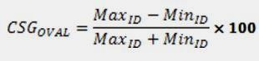

## So the image naming of equation will increase sequentially as

**“SPE-[article code]-MS_Eq_02.tif” Same is case for Figure also**

1. If you find the data “**Error! Reference source not found**” in your input file. Report the same to production team.

**REQUIRED FIELDS**

## The required fields are

* Abstract
* Doi
* Language
* Manuscript number
* Organization
* Page count
* Society code
* Year
* Title
* Author filed [name, affiliation]
* Meeting code

1. In body part all figure and table position would be float
2. Back matter Appendix section figure and table would be anchor
3. Ref 1 should be Ref<xref ref-type=”bibr” rid=”R1”>1</xref>
4. In pdf Appendix will appear same as link as mentioned (see appendix) the provide the link
5. Validate the files by using “SCJATS-journalpublishing.xsd”
6. DTD – http://jats.nlm.nih.gov/publishing/tag-library/1.0/index.html